Breadth First Search Problem in Python:
Aim:
To implement the Breadth First Search (BFS) algorithm to traverse a graph and visit all reachable nodes.
Objective:
- Implement the Breadth First Search (BFS) algorithm in Python.
- Traverse a graph level by level from a given starting node.
- Explore all reachable nodes using a queue data structure.
- Understand the application of BFS as an uninformed search algorithm in Artificial Intelligence.
Algorithm:
- Create a graph using an adjacency list.
- Initialize an empty queue.
- Mark the starting node as visited and enqueue it.
- Repeat until the queue is empty:
- Remove the front node from the queue.
- Display the node.
- Visit all its unvisited adjacent nodes.
- Mark them as visited and enqueue them.
- Stop when all reachable nodes have been visited.

Flow Chart:
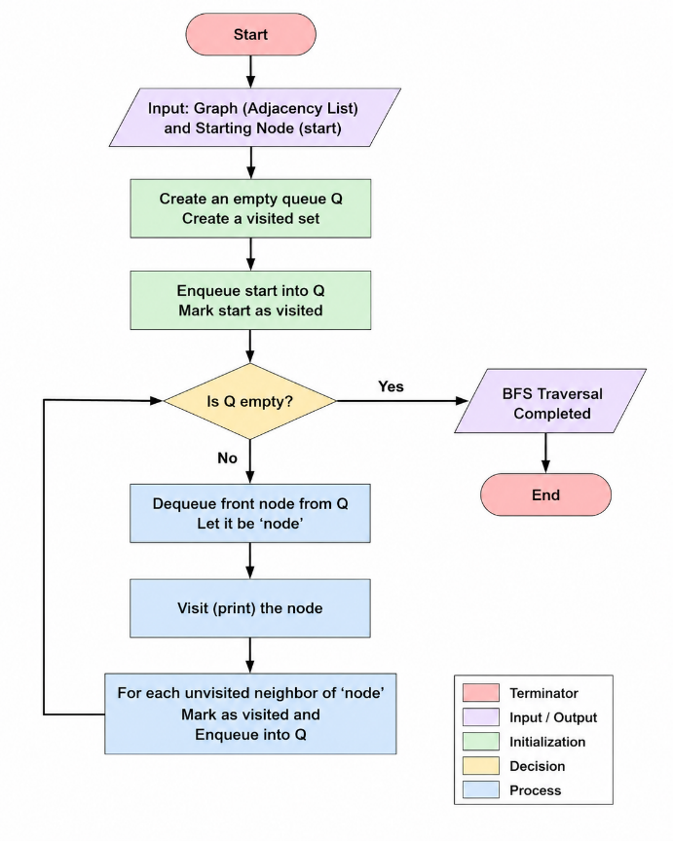
Python Code:
from collections import deque
# BFS Function
def bfs(graph, start):
visited = []
queue = deque()
visited.append(start)
queue.append(start)
print("\nBreadth First Search Traversal:")
while queue:
node = queue.popleft()
print(node, end=" ")
for neighbour in graph[node]:
if neighbour not in visited:
visited.append(neighbour)
queue.append(neighbour)
# Main Program
graph = {}
n = int(input("Enter the number of vertices: "))
for i in range(n):
vertex = input(f"Enter vertex {i+1}: ")
neighbours = input(f"Enter adjacent vertices of {vertex} (space-separated): ").split()
graph[vertex] = neighbours
start = input("\nEnter the starting vertex: ")
if start in graph:
bfs(graph, start)
else:
print ("Starting vertex not found in the graph.")
Sample Output:
Breadth First Search Traversal:
A B C D E
Result:
